Project 1

<Hazard>

CIS 5- 41202

David

Duran

Due Date: 02/02/16

Introduction:

Players 2+

Age range Adult

Setup time < 1 minute

Random chance High, Dice rolling

Skill(s) required Betting

Rules: Any number may play, but only one player – the **caster** – has the dice at any one time.

In each round, the caster specifies a number between 5 and 9 inclusive: this is the **main**. He then throws two dice.

* If he rolls the main, he wins (**throws in** or **nicks**).
* If he rolls a 2 or a 3, he loses (**throws out**).
* If he rolls an 11 or 12, the result depends on the main:
  + with a main of 5 or 9, he throws out with both an 11 and a 12;
  + with a main of 6 or 8, he throws out with an 11 but nicks with a 12;
  + with a main of 7, he nicks with an 11 but throws out with a 12.
* If he neither nicks nor throws out, the number thrown is called the **chance**. He throws the dice again:
  + if he rolls the chance, he wins;
  + if he rolls the main, he **loses** (unlike on the first throw);
  + if he rolls neither, he keeps throwing until he rolls one or the other, winning with the chance and losing with the main.

FlowChart

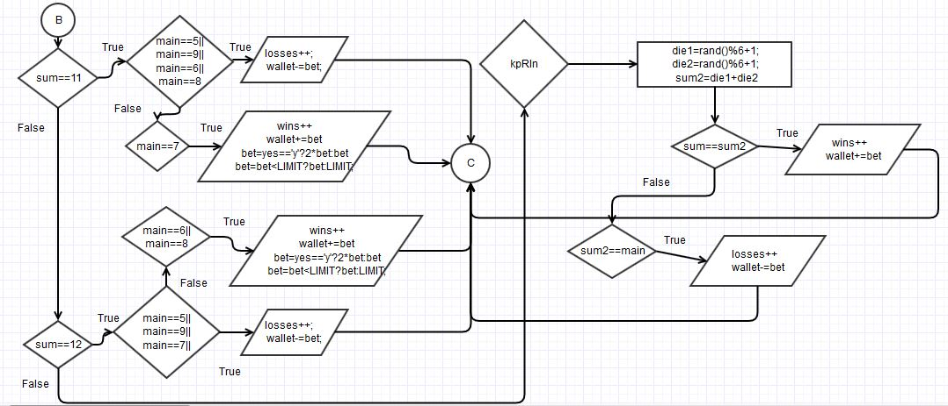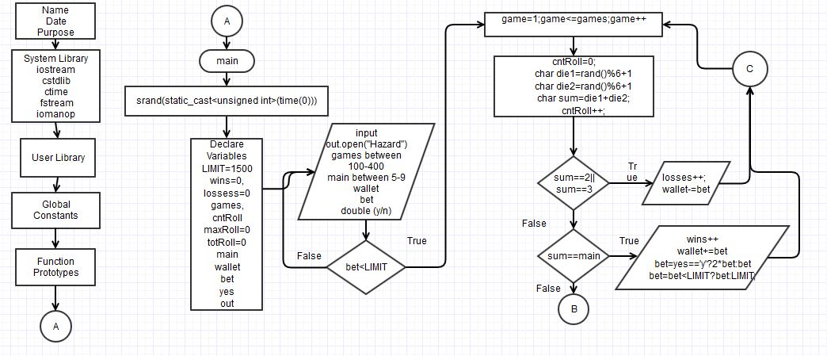

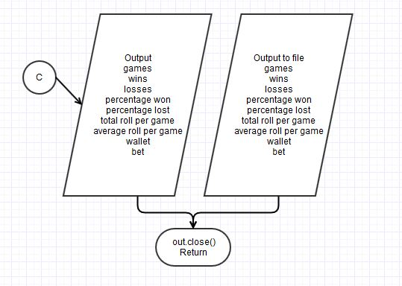

Pusedo Code

//System Libraries

//I/O

//srand and rand function

//time to set the random number seed

//File I/O

//Formatting

//User Libraries

//Global Constants

//Function Prototypes

// Execution Begins Here

//Set the random number seed

//Declare and initialize variables

//Table single bet limit = $1500

//$'s

//Character to answer if winning double the bet

//Open the file

//Input data

//Modify the bet based upon the table limit

//Ternary Operator

//Throw the dice

//Number between [1,6]

//Number between [1,6]

//Every time dice are thrown, Increment

//Another Ternary

//Roll again

//Number between [1,6]

//Number between [1,6]

//Output the results to the Screen

//Output the results to a file

//Exit stage right Close File

Sources:

1. <https://en.wikipedia.org/wiki/Hazard_%28game%29>